Alliance School of Advanced Computing

Course Name: Graph Analytics
Course Code: EITC 302
Assignment No:

Name of the Student: NAVYA S

Registration Number: 2411021060373

A. Title of The Problem:
Cut the Tree

B. Problem Statement in details:
We are given an undirected tree with n vertices numbered from 1 to n, rooted at vertex 1. Each vertex holds a data value, and the sum of a tree is the total of all its vertices' data values. If we remove one edge from the tree, it splits into two smaller trees. The difference between these two trees is defined as the absolute value of the difference between their sums.
The task is to determine which single edge to cut so that the resulting two trees have the minimum possible difference between their sums, and to return that minimum difference.
Sample Input: n = 6, data = [100, 200, 100, 500, 100, 600], edges = [(1,2), (2,3), (2,5), (4,5), (5,6)]. Sample Output: 400.

C. HackerRank/Leetcode Link of the problem (If applicable): https://www.hackerrank.com/challenges/cut-the-tree/problem

D. Student’s Github link of report and code upload, along with the readme file: https://github.com/NAVYAS367/cut-the-tree

E. Solution Steps/Algorithm:
1. Build an adjacency list representation of the tree from the given edges.
2. Compute the total sum of all node values in the tree.
3. Root the tree at vertex 1 and perform a DFS (implemented iteratively to avoid recursion-depth issues) to determine a processing order and each node's parent.
4. Process nodes in reverse DFS order, accumulating each node's own value into its subtree sum and then adding that subtree sum to its parent's subtree sum (bottom-up accumulation).
5. For every non-root node, cutting the edge to its parent separates the tree into that node's subtree (sum = subtree_sum[node]) and the rest of the tree (sum = total − subtree_sum[node]). The difference for that cut is |total − 2 × subtree_sum[node]|.
6. Track the minimum difference across all possible edge cuts and return it as the answer.

F. Code developed:
import sys
from collections import defaultdict

def cutTheTree(data, edges):
n = len(data)
total = sum(data)
adj = defaultdict(list)
for a, b in edges:
adj[a].append(b)
adj[b].append(a)

subtree_sum = [0] * (n + 1)
visited = [False] * (n + 1)
min_diff = float('inf')

# Iterative DFS to avoid recursion limits on large trees
parent = [0] * (n + 1)
order = []
stack = [1]
visited[1] = True
while stack:
node = stack.pop()
order.append(node)
for nei in adj[node]:
if not visited[nei]:
visited[nei] = True
parent[nei] = node
stack.append(nei)

for node in reversed(order):
subtree_sum[node] += data[node - 1]
if parent[node] != 0:
subtree_sum[parent[node]] += subtree_sum[node]

for node in order:
if node != 1:
diff = abs(total - 2 * subtree_sum[node])
min_diff = min(min_diff, diff)

return min_diff

if __name__ == "__main__":
n = int(input())
data = list(map(int, input().split()))
edges = []
for _ in range(n - 1):
a, b = map(int, input().split())
edges.append((a, b))
print(cutTheTree(data, edges))

G. HackerRank test case passed Screenshot or Output screenshot (Mandatory):
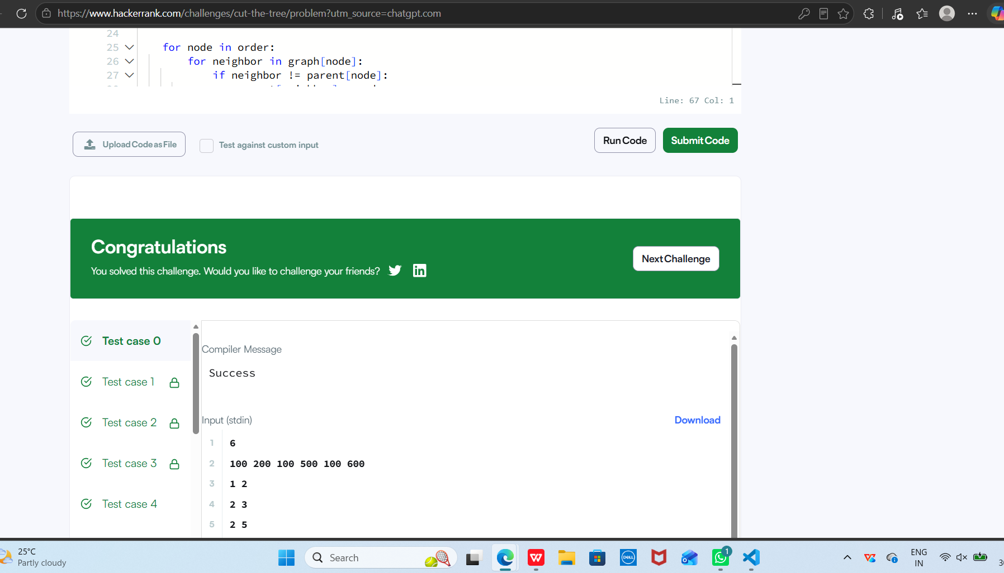

H. Observation:
The problem reduces to a single-pass tree DFS once we realise that cutting an edge (parent, child) always separates the tree into exactly the child's subtree and everything else. This means we only need one bottom-up traversal to compute all subtree sums, rather than recomputing sums for every possible cut separately.
Time complexity is O(n) since each vertex and edge is visited once during the DFS and once during the difference calculation. Space complexity is O(n) for the adjacency list and auxiliary arrays. An iterative DFS was used instead of a recursive one to safely handle trees with a large number of vertices without hitting Python's recursion limit.

